**ANSWERS**

**Lab 7**

Elevation Surface Visualization,

Analysis, and Modeling

**Deliverables:**

* 1. Question 1-9
  2. Graphics 1-6
  3. Submit as one PDF on Canvas.

**QUESTION 1: What are slope, aspect, and hillshade? (Hint: Read the Help if you need. Cite where necessary). What are these tools doing?**

Courtesy of ESRI:

Slope is the gradient or steepness over cells.

The aspect identifies the compass direction that the downhill slope faces for each location.

The HillShade tool creates a shaded relief raster from a raster. The illumination source is considered to be at infinity.

The contour tool creates a feature class of contours from a raster surface. Contours are polygons of constant elevation.

**QUESTION 2: What are the settings that determine where the shadows fall on the hillshade?**

**Azimuth** – the azimuth angle of the light source. The azimuth is expressed in positive degrees from 0 to 360, measured clockwise from north.

**Altitude** – the angle of the light source above the horizon. The altitude is expressed in positive degrees, with 0 degrees at the horizon and 90 degrees directly overhead. The default is 45 degrees.

**Model** **Shadows** - Type of shaded relief to be generated.

**Z** **Factor** - Number of ground x,y units in one surface z-unit. The z-factor adjusts the units of measure for the z-units when they are different from the x,y units of the input surface. The z-values of the input surface are multiplied by the z-factor when calculating the final output surface.

**QUESTION 3: What fields are in the TwoViewpoints layer?**

ObjectID and Shape

**QUESTION 4: Which point has a larger viewshed? What is the elevation of this point?**

Point 1 has a larger viewshed, at an elevation of 8084 ft.

**QUESTION 5: What tools are run in the model?**

Raster Calculators are run on Slope, McDEM_10m, as well as goodslope, goodaspect, and goodelev afterwards. Reclassify is run on Aspect.

**QUESTION 6: What are the parameters and/or equations used in these tools? Write up what these parameters and equations are doing in plain English (short paragraph).**

Raster Calculator (3) is selecting raster cells where slope is less than 40.

The reclassify tool for aspect reclassifies values between -1 and 0 to 0, 0 and 22.5 to 1, 22.5 and 337.5 to 0, 337.5 to 359.9999 to 1.

Raster Calculator is selecting cells where the elevation (McDEM_10m) is greater than 7875.

The final raster calculator multiplies the values of goodelev by goodslope by goodaspect.

**QUESTION 7: Based on the viewsheds and denning habitat, suggest which viewshed would be best for observing denning habitat and why?**

According to the raster calculations in the model listed above, viewshed 1 is best for observing denning habitat. Its output raster has a count of 773852, compared to the count of 23944 for viewshed 2.

**QUESTION 8: Justify your symbolization method and color choice, why did you use Classify or Stretch? If you chose Classify, why switch to Defined Interval? How would a legend look different because of your choices?**

I chose the stretch method of symbology. Stretching is continuous, and I think this makes more sense for elevation than classifying it into discrete bands. With a discrete scheme, we would have more accuracy in the visualization with the more bands we add, as the amount of values a single band has to represent is decreased. However, as we add more bands, we would start to approximate a continuous scheme.

I chose a color scheme that maps areas of low elevation to green, and areas of high elevation to brown. I chose this because there is typically less vegetation on top of hills where elevation is highest.

**QUESTION 9: What is “draping” a layer in ArcScene? What is the layer being draped onto?**

According to ESRI, draped layers “use other layers as elevation sources. Drape a layer to show it on a 3D surface. For example, you might drape an aerial photo and its associated features on a mountaintop.” The layer is being draped onto the DEM.

**GRAPHIC 1: Take a screenshot of your new attribute table for the TwoViewpoints layer.**

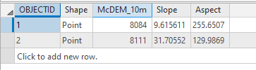

**GRAPHIC 2: Take a screenshot of the WolverineElevations layer. You may want to turn off the other layers if they are obscuring your results.**

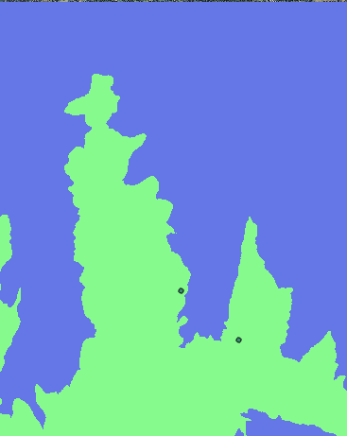

**GRAPHIC 3: Include a screenshot of this map in your deliverables**

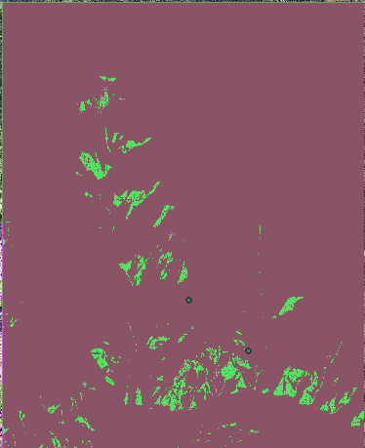

**GRAPHIC 4: Put this map in Layout view. Add a title and scale bar. No need to add a legend because legends in ArcGIS don’t take into account the transparency you added, so your colors won’t match your legend anyways. Export the map as a .pdf.**

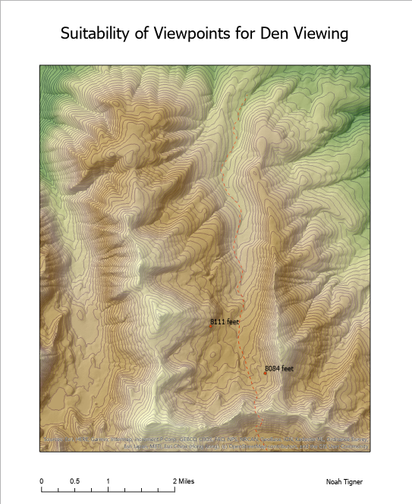

**GRAPHIC 5: Screenshot of 3D Hillshade**

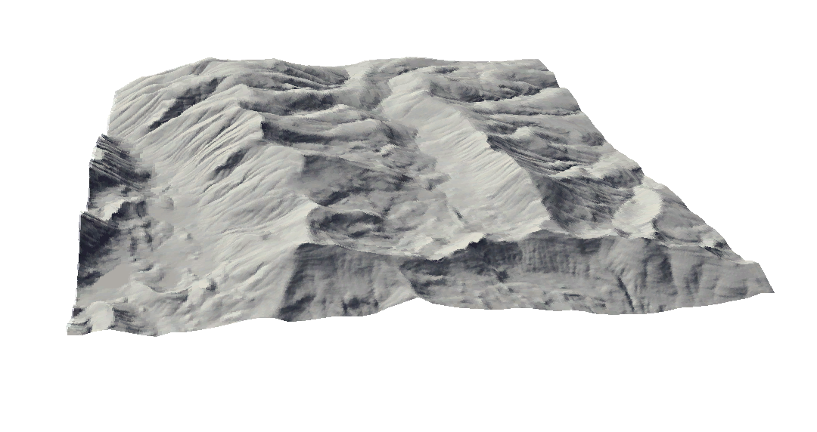

**GRAPHIC 6: Screenshot of 3D Ortho Photo with trail and viewpoints on top**

